**2016 复函数空间与算子理论研讨会**

2016 复函数空间与算子理论研讨会(2016 Workshop on Complex Function Space Theory and Operator Theory)将于2016年12月15日至12月18日在浙江杭州举行, 会议由浙江科技学院理学院主办、承办。本次会议旨在讨论复函数空间与算子理论领域的最新研究成果和进展，加强国内外相关学科专家学者的交流与合作，促进学科间的交叉、渗透和发展。本次会议得到国内外多位学者的支持.特别是:国际分析领域的二位著名学者:美国纽约州立大学奥尔巴尼分校Kehe Zhu教授和美国加州大学尔湾分校Song-Ying Li教授,他们将作会议主题报告.下面是会议报告的详细安排:

学术报告安排

12．16上午

|  |  |  |  |
| --- | --- | --- | --- |
| 时间 | 报告人 | 题目 | 主持人 |
| 9：00—9:40 | Kehe Zhu  (美国纽约州立大学奥尔巴尼分校) | COMMUTATIVITY OF OPERATOR TUPLES | 姚璧芸 |
| 9：40—10:20 | Song-Ying Li  (美国加州大学尔湾分校) | On Bounded,Compact Composition operators on Hardy and Bergman space over a bounded pseusoconvex domain in C^n |
| 10:20-10：40 |  | 茶歇 |  |
| 10:40-11：05 | 刘聪文  (中国科技大学) | The Bloch space over the Siegel upper half-space | 胡璋剑 |
| 11:05-11：30 | 王建飞  (浙江师大) | Schwarz lemma at the boundary of the unit ball in Cn and its applications |
| 11:30-11：45 | 林桂娟  (福建师范大学) | The sharp upper bounds for the first positive eigenvalue |
| 11:45-12：00 | 彭伟强  (河北工业大学) | CONVEXITY OF AREA INTEGRAL MEANS FOR ANALYTIC FUNCTIONS |

学术报告安排

12．16下午

|  |  |  |  |
| --- | --- | --- | --- |
| 时间 | 报告人 | 题目 | 主持人 |
| 14:00—14:25 | 刘永民  (江苏师范大学) | Riemann-Stieltjes 算子的本性范数 | 娄增建 |
| 14:25—14:50 | 王春杰  (河北工业大学) | Domination and some related topics in operator theory |
| 14:50—15:15 | 刘军明  (广东工业大学) | 解析 Morrey space 的一些进展 |
| 15:15—15:30 | 张琦琦  (福建师范大学) | On the boundary regularity and rigidity for Bakry-Emery-Kohn harmonic functions in Bergman metric on the unit ball in |
| 15:30-15：50 |  | 茶歇 |  |
| 15:50-16：15 | 罗罗  (中国科学技术大学) | The boundedness and the compactness of weighted composition operators between the weighted Bergman spaces of the unit disc | 叶善力 |
| 16:15-16：40 | 刘小松  (嘉应学院) | NORM AND ESSENTIAL NORM OF WEIGHTED  COMPOSITION OPERATORS ON THE BLOCH AND BMOA |
| 16:40-16：55 | 林秉文  (浙江科技学院) | 实单位球上的精确Forelli-Rudin型估计的简单应用 |
| 16:55-17：10 | 李英  (河北工业大学) | Domination in weighted Lebesgue spaces |

报告摘要

(按报告顺序排序)

**COMMUTATIVITY OF OPERATOR TUPLES**

**朱克和**

**State university of New York at Albany**

For an n-tuple  of compact operators. we define the joint point spectrum of A to be the set



We prove in several situations that the operators in A pairwise commute if and only if  consists of countably many, locally finite, hyperplanes in . In particular, we show that if A is an n-tuple of  normal matrices, these matrices pairwise commute if and only if the Polynomial



is completely reducible, namely,



can be factored into the product of linear polynomials.

**On Bounded,Compact Composition operators on Hardy and Bergman space over a bounded pseusoconvex domain in C^n**

**李松鹰**

**美国加州大学尔湾分校**

I will talk about some joint works with Hyungwoon Koo, from Korea University.  will discussed some results on boundedness and compactness of composition operators of Hardy and Bergman space on a bounded  pseudo convex domain in C^n.

**The Bloch space over the Siegel upper half-space**

**刘聪文**

**中国科学技术大学**

**Schwarz lemma at the boundary of the unit ball in Cn and its applications**

**王建飞**

**浙江师范大学**

This talk, we first establish a new type of the classical boundary Schwarz  
lemma for holomorphic self-mappings of the unit ball in Cn. We then apply our new  
Schwarz lemma to study problems from the geometric function theory in several complex variables. This work is jointed with Prof. Taishun Liu and Xiaomin Tang.

**The sharp upper bounds for the first positive eigenvalue**

**林桂娟**

**福建师范大学**

We give sharp and explicit upper bounds for the first positive eigenvalue of

 of the Kohn-Laplacian on compact strictly pseudoconvex hypersurfaces in  in terms of their defining functions. As an application, we show that in the family of real ellipsoids,  has a unique maximum value at the CR sphere.

**CONVEXITY OF AREA INTEGRAL MEANS FOR ANALYTIC FUNCTIONS**

**彭伟强**

**河北工业大学**

We show that the  integral mean on rD of an analytic function in the unit disk D with respect to the weighted area measure is a convex function of r on (0,1) when c. We also show with examples that the range  is best possible.

**Riemann-Stieltjes 算子的本性范数**

**刘永民**

**江苏师范大学**

建立了从Hardy空间到Zygmund 型空间 Riemann-Stieltjes 算子 和  的有界性和紧性的特征; 进一步构造了中一些检验函数, 运用本性范数的定义与解析函数的性质, 给出了算子 和 本性范数的估计.

**Domination and some related topics in operator theory**

**王春杰**

**河北工业大学**

In 1991 B. Korenblum introduced the idea of domination in Bergman spaces when he studied the so-called Korenblum's maximum principle. In this talk we will discuss domination mainly in Bergman spaces and some related topics in operator theory.

**解析 Morrey space 的一些进展**

**刘军明**

**广东工业大学**

我们将介绍解析Morrey 空间的一些理论，及相关进展。

**On the boundary regularity and rigidity for Bakry-Emery-Kohn harmonic functions in Bergman metric on the unit ball in **

**张琦琦**

**福建师范大学**

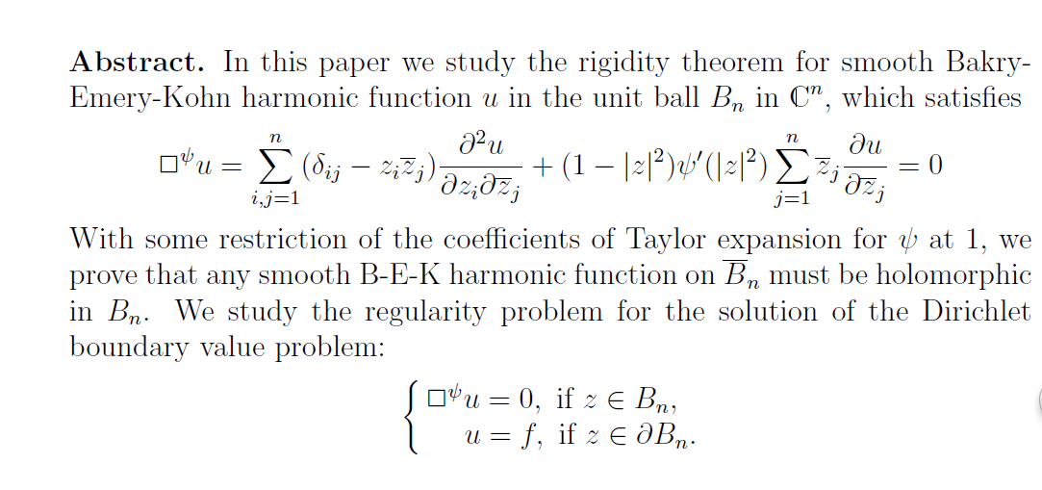

**The boundedness and the compactness of weighted composition operators between the weighted Bergman spaces of the unit disc**

**罗罗**

We characterize the boundedness and the compactness of weighted composition operators C:\Users\ysl\AppData\Local\Temp\ksohtml\wpsE41A.tmp.png between the weighted Bergman spaces of the unit disc in terms of both the Nevanlinna counting function associated to the symbols C:\Users\ysl\AppData\Local\Temp\ksohtml\wpsE42B.tmp.png and C:\Users\ysl\AppData\Local\Temp\ksohtml\wpsE42C.tmp.png and the Carleson measure.

**NORM AND ESSENTIAL NORM OF WEIGHTED**

**COMPOSITION OPERATORS ON THE BLOCH AND BMOA**

**刘小松**

**嘉应学院**

We give some new estimates for the norm and essential norm of weighted composition operators on the Bloch and BMOA. As corollaries, we obtain some new characterizations of the boundedness and compactness of weighted composition operators on the Bloch and BMOA.

**实单位球上的精确Forelli-Rudin型估计的简单应用**

**林秉文**

**浙江科技学院**

利用实单位球上的精确Forelli-Rudin型估计，简化了一个与调和函数有关的精确不等式的证明。我们还讨论了一个Hardy-Littlewood型不等式

C:\Users\ysl\AppData\Local\Temp\ksohtml\wps667D.tmp.png

的常数与指数，其中的常数C:\Users\ysl\AppData\Local\Temp\ksohtml\wps668D.tmp.png给出了一个确切的值，指数C:\Users\ysl\AppData\Local\Temp\ksohtml\wps669E.tmp.png被证明是最优的。

**Domination in weighted Lebesgue spaces**

**李英**

**河北工业大学**

It is well known that  in  where ,  and . In this talk we give a similar result in the weighted Lebesgue space .